Pengajuan Dana 02 Agustus 2024

1. Pasang Modul Transmisi GLE 450

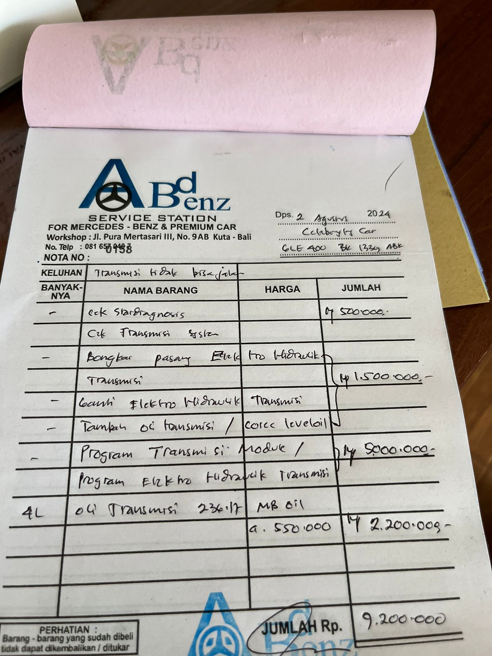

1. Service Kaki-kaki Voxy

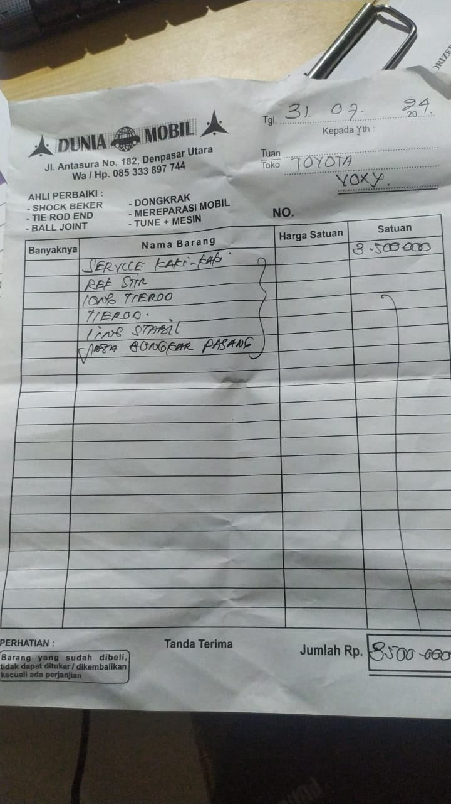

1. Pajak Jimny

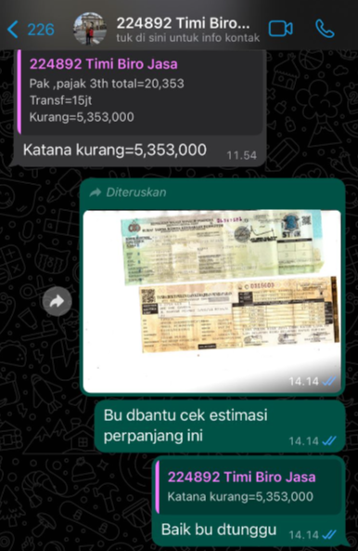

1. Program Kunci Duplikat

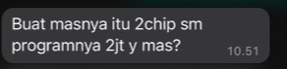

1. Towing BMW Z4 (via Telfon)

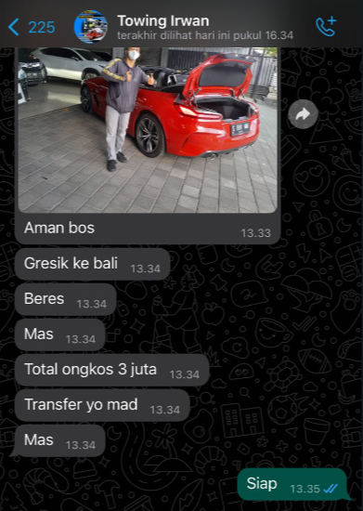

1. 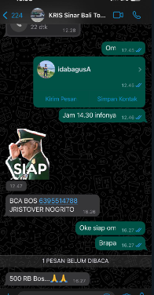Towing Clubman
2. Surat Jalan 3 Mobil

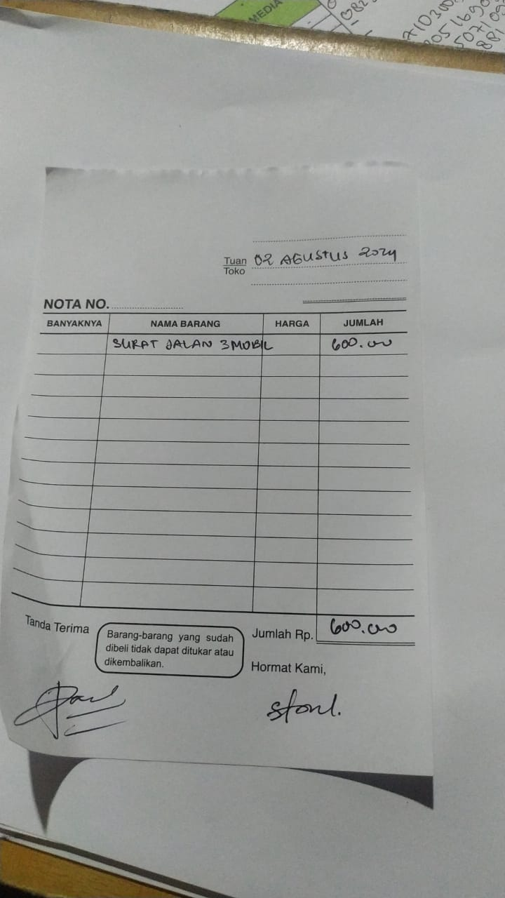

1. Samsat Yaris Cross

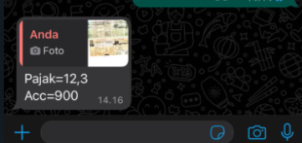

1. 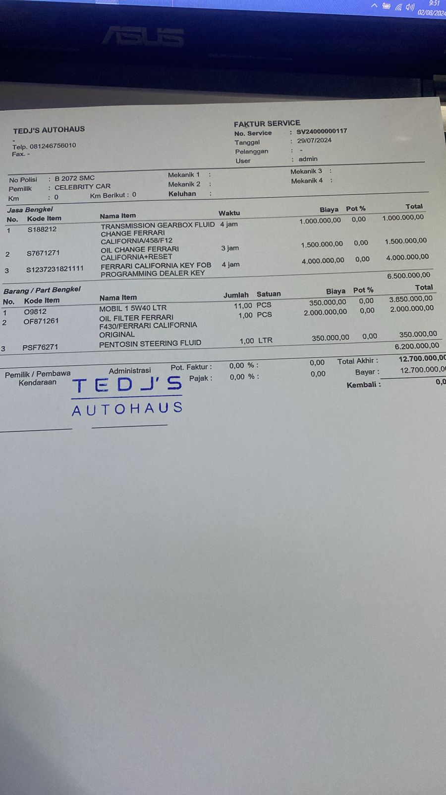Service Ferrari Merah
2. Service Door Trim Ferrari Merah

